Lab-5 Report
4-bit adder & 4-bit full binary subtractor

MIRIYALA PRANAY KAMAL
200030033

Aim: To study the 4-bit adder digital IC 74LS83 and use it to implement a 4-bit full binary subtractor circuit which is controlled by signal CTRL.

Components used:

- Digital adder IC 74LS83
- Digital XOR IC 74HC86N
- Power supply
- Breadboard
- 1k resistor arrays (X2)
- LED display
- DIP switches

Design Procedure & Circuit diagram:

Problem Statements:

- Design and implement a half adder circuit using a minimum number of 2 input gates.

- Familiarize 74LS83 IC and implement a controlled 4-bit adder/subtractor circuit which is controlled by signal CTRL using 74LS83 and minimum number of 2-input gates.

CTRL | OPERATION
1 | Addition
0 | Subtraction (either 1’s or 2’s complement method)

Solution:

HALF ADDER CIRCUIT

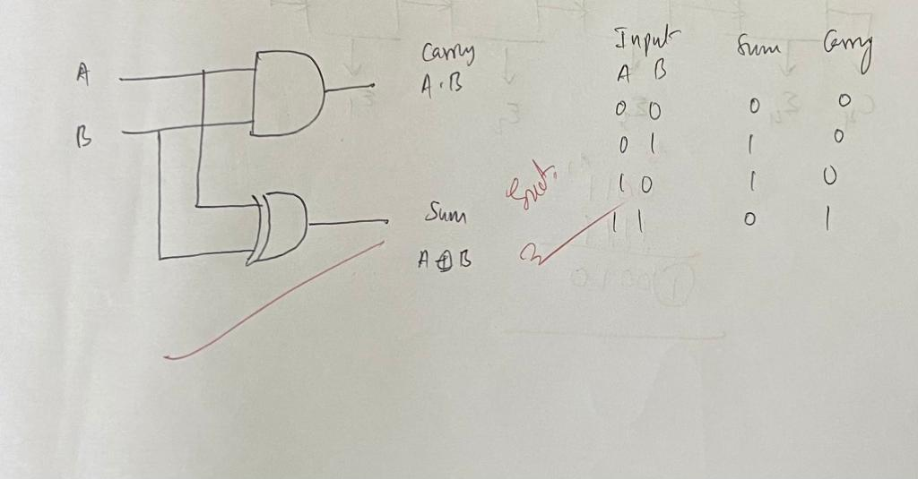

FULL ADDER CIRCUIT
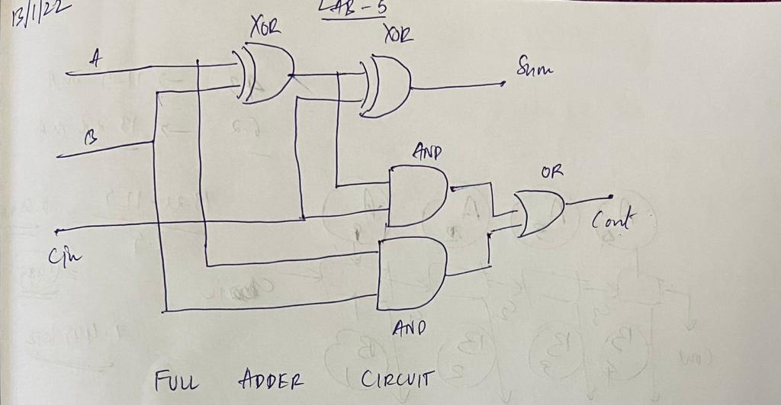

FULL SUBTRACTOR CIRCUIT
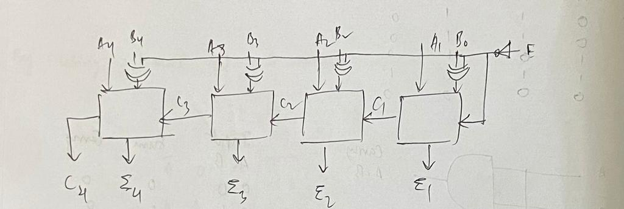

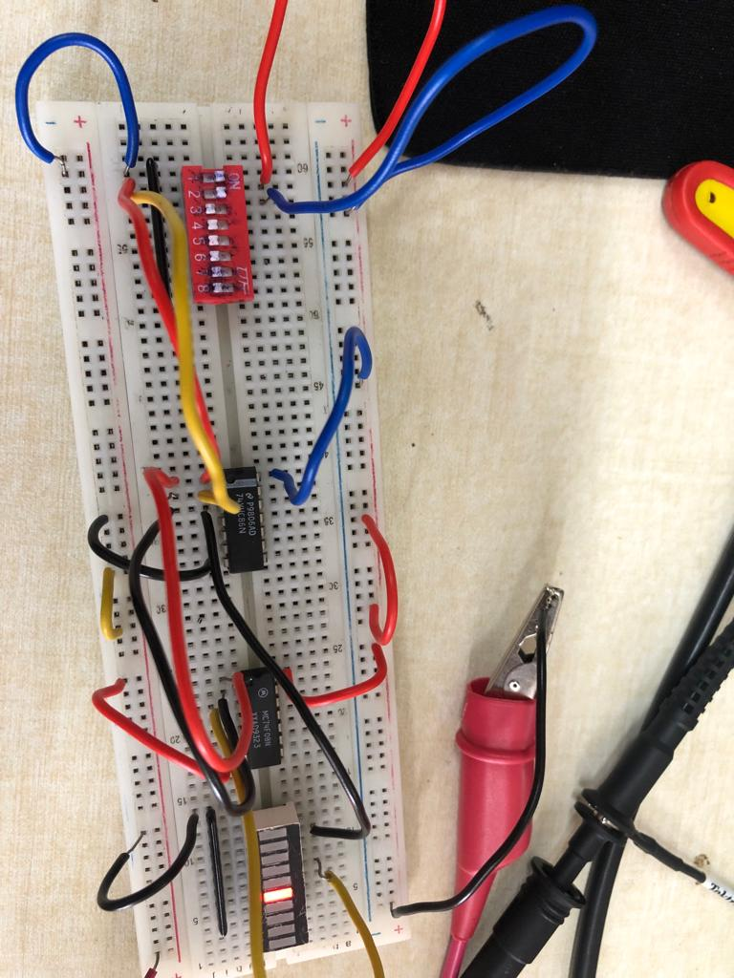
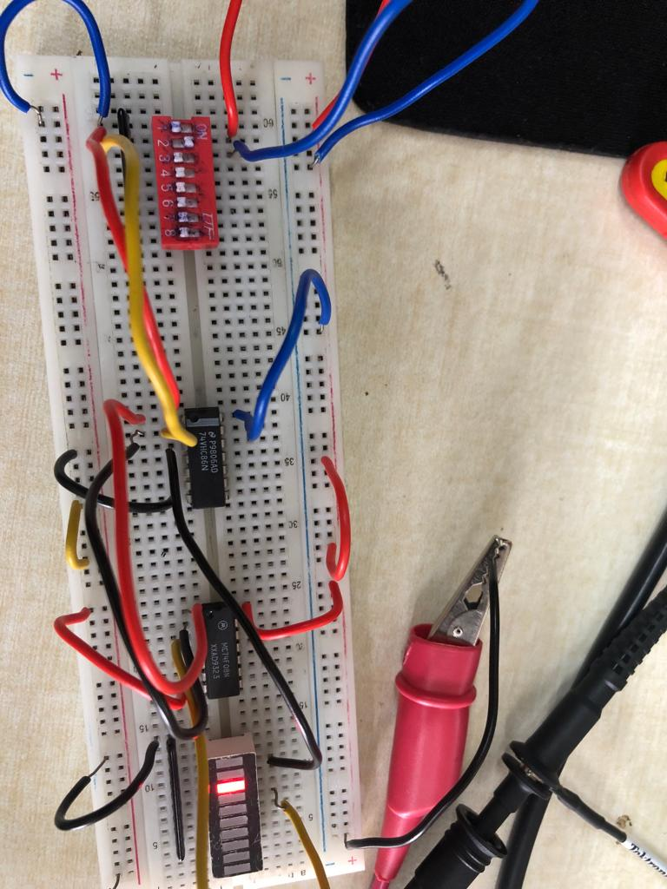
Circuit Snapshots:

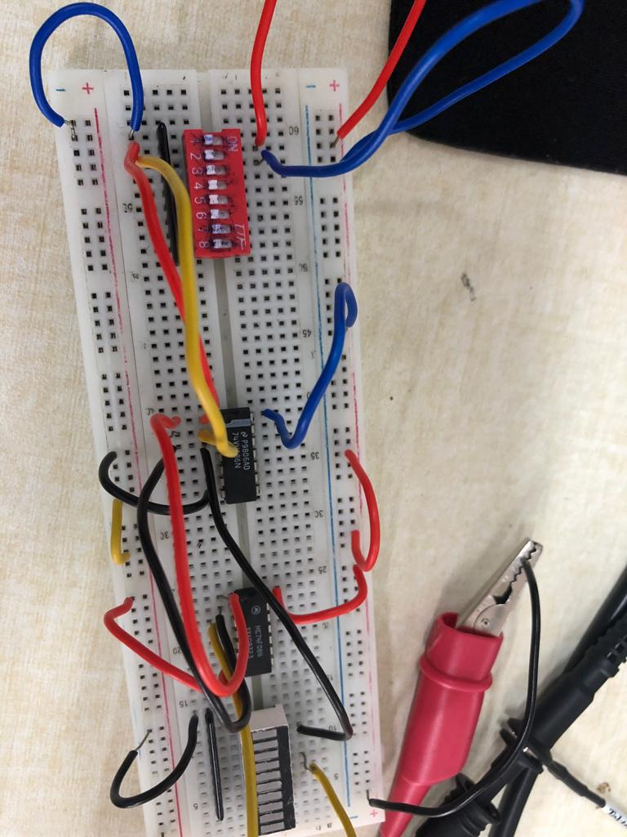

Half Adder circuit
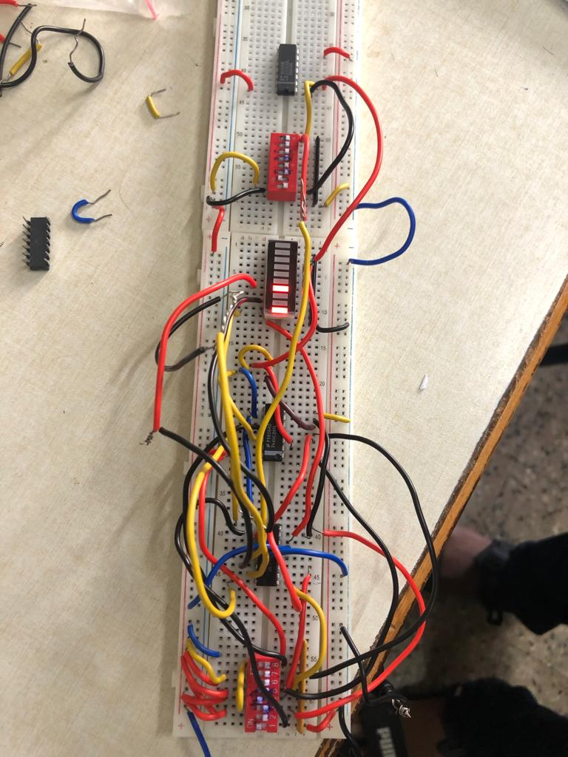

4-bit full binary subtractor circuit which is controlled by signal CTRL

Results and Discussions:

The snapshots corresponding to each of the gates exactly represents the required logic hence we have implemented the solution using half adder circuit and both 2’s complement and 1’s complement subtractor and full adder circuit.

Conclusions:
I’ve learnt that Digital IC adder 74LS83 can be used to implement both adder and subtractor circuits. So, this way, because of 2’s complement method of subtraction, we don’t need a separate piece of hardware to perform binary subtraction since, both the adder and subtractor functionality can be obtained using the same IC 74LS83 circuit without change of the IC for subtraction.

